Report on Mini Project
Name : Akash. P
Batch : TN-DA-ANB11
Mail Id : akashraj894@gmail.com
Contact No : 7358545758
Tittle : Dirty Finance
Project Domain : Finance
Data set year Timeline : 2023 Dataset
Submission : 07-01-2025
Mentor : Kumaran. M

Raw Data set : https://docs.google.com/spreadsheets/d/1AQUS-T5dK7Bf00cB0zf9bDvRUk07huhO/edit?usp=sharing&ouid=108761371381683603380&rtpof=true&sd=true

Cleaned Dataset : https://docs.google.com/spreadsheets/d/1a9xAhupc4kL4QP5WVaDxNwie1WM4S1Wx/edit?usp=sharing&ouid=108761371381683603380&rtpof=true&sd=true
Visuals Dataset: https://drive.google.com/file/d/1o4UG2jpYtPYuZmtP8XF54VUzK2keq19U/view?usp=sharing

Dirty Finance Data Set-Data Cleaning, Data Transformation, and Data Visualization
This project aims to analyze and visualize financial transaction data to identify patterns in user behavior, transaction types, and financial risk indicators. The dataset contains timestamped transaction records with details such as user IDs, transaction amounts, transaction types (deposit, withdrawal, transfer), account balances, and investment duration.
In addition, the dataset includes key economic and market indicators such as market volatility index, interest rates, inflation rates, and stock index changes, along with user-specific attributes like credit score, device CPU and memory usage, and assigned risk levels.
The analysis focuses on understanding how financial behavior correlates with market conditions, credit scores, and risk levels. Data visualization techniques are used to uncover trends, detect anomalies, and support insights related to financial stability, transaction patterns, and risk assessment.
Derived Columns for Enhanced Analysis
To enhance the financial and risk-based analysis, multiple derived columns were created from the existing dataset to support deeper insights and validation:
- Net Transaction Amount – Calculated after considering transaction type and balance impact to validate actual money flow.
- Transaction Month – Extracted from the transaction timestamp to analyze monthly transaction trends.
- Transaction Year – Derived to evaluate year-over-year transaction behavior.
- Transaction Type Group – Categorized as Deposit, Withdrawal, or Transfer for behavioral comparison.
- Risk Category – Classified based on credit score and assigned risk level to assess financial risk patterns.
- Market Condition Index – Derived using volatility index, inflation rate, and interest rate to study market impact.
- User Activity Level – Grouped based on transaction frequency and amount

Key Analysis Questions Addressed
The analysis and visualizations help answer the following questions:
- How do transaction patterns vary across different transaction types?
- What is the relationship between credit score and risk level?
- How do market conditions impact transaction behavior?
- Which users show high-risk financial behavior?
- Are there anomalies based on transaction amount, frequency, or system usage?
- How do deposits and withdrawals trend over time?

Tools and Technologies Used
- Microsoft Excel – Used for data cleaning, handling missing values, formatting, and creating derived columns.
- Power BI – Used for interactive dashboards and advanced financial visualizations.
- Data Visualization Techniques – Applied using charts, KPIs, trend lines, and filters to present insights clearly.

DATA CLEANING
1.Proper the headings: Proper the headings to removed inconsistency in headings.

2.To separate the date and time: Used Delimited

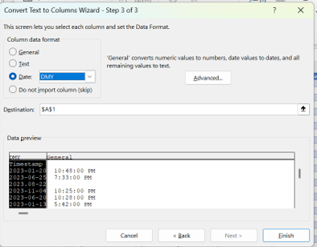
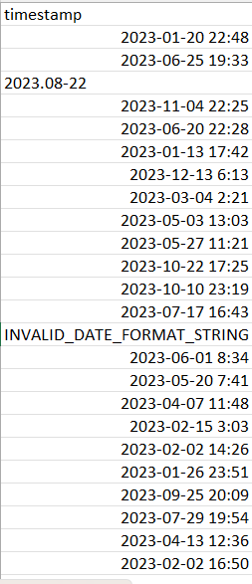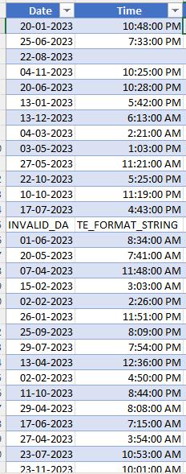
3.To remove inconsistency in date: Used Find and replaced

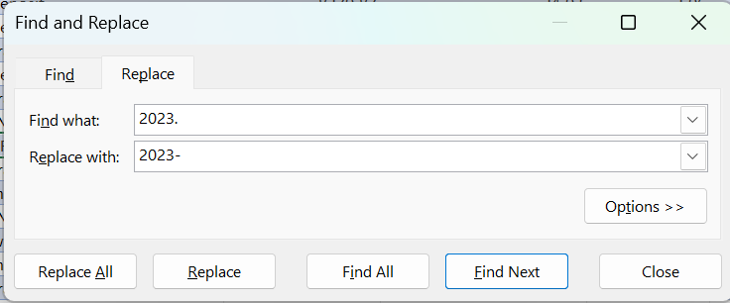

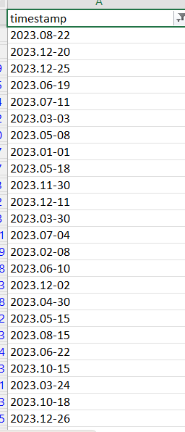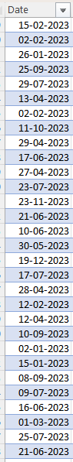

4.To remove inconsistency in transaction amount: Used Find and replaced
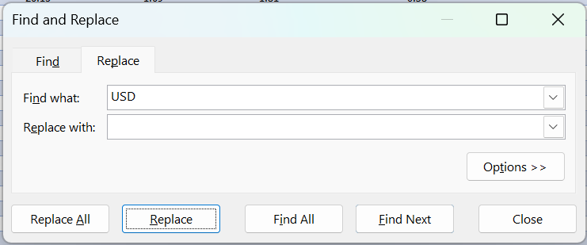
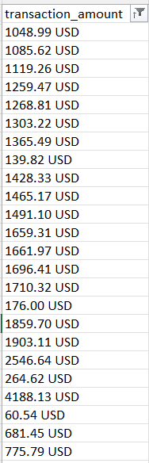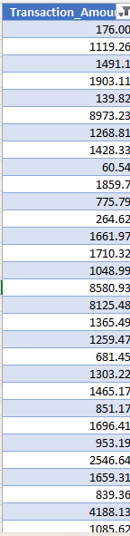
5.To remove typo errors in Transaction Type: Select and paste the correct spelling

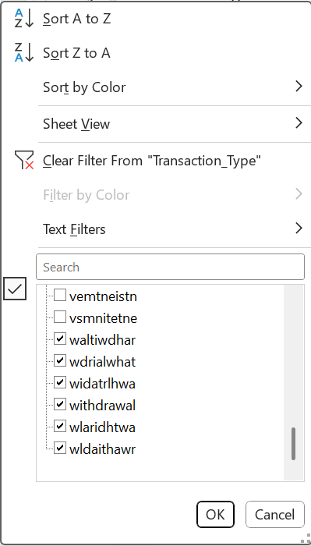

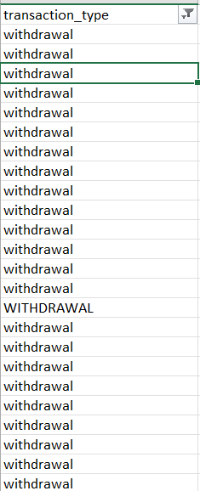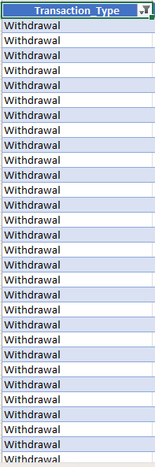
6.To find the invalid DA in Date: Used power query editor

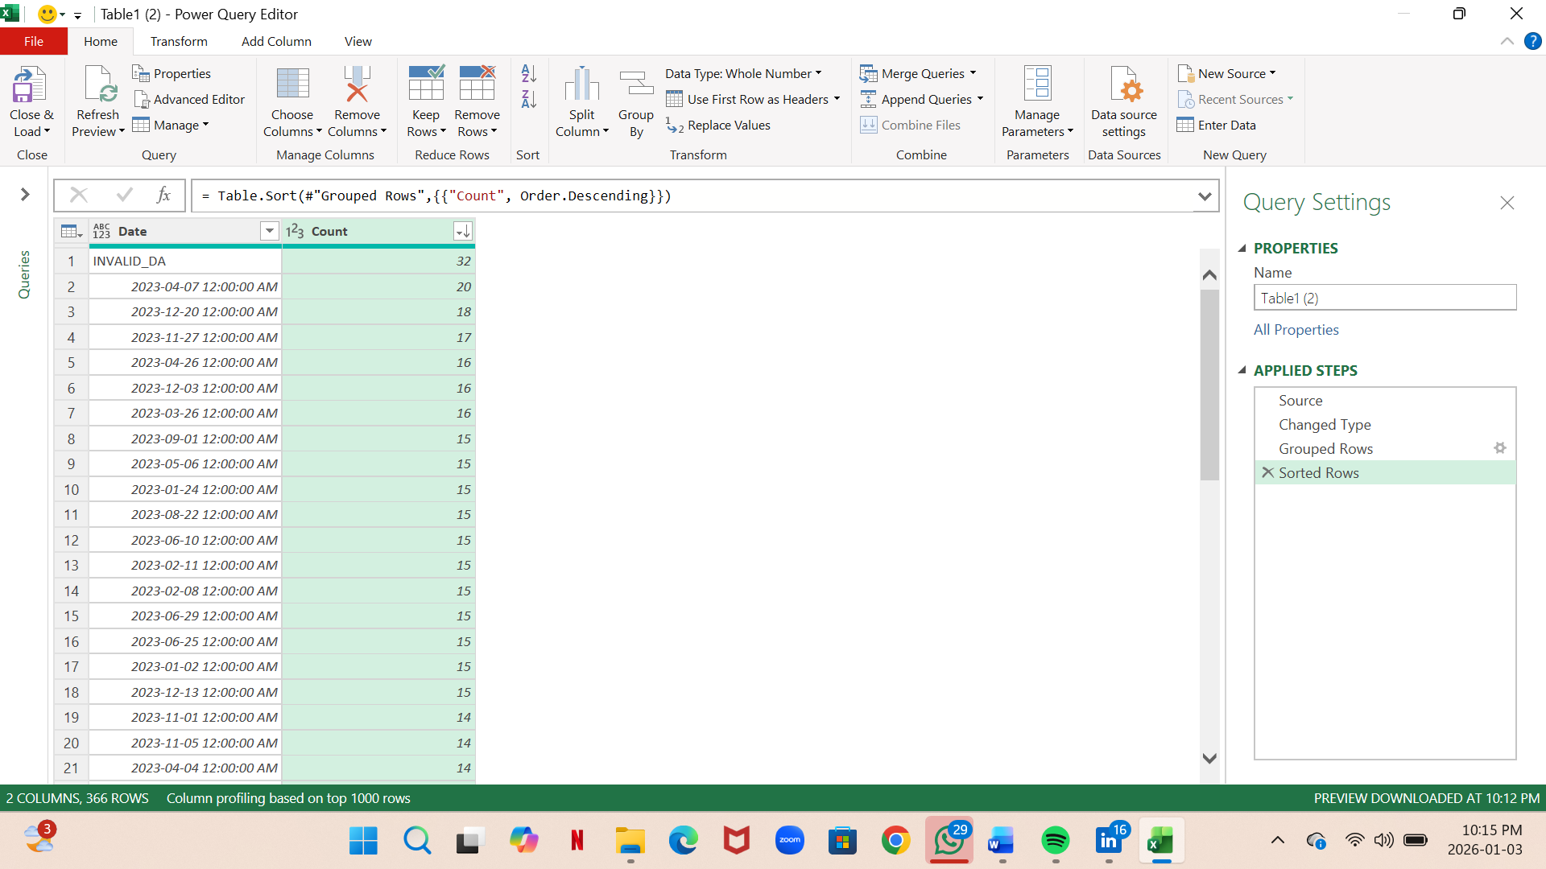

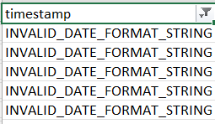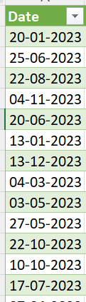

7.To find the null in Time: Used power query editor

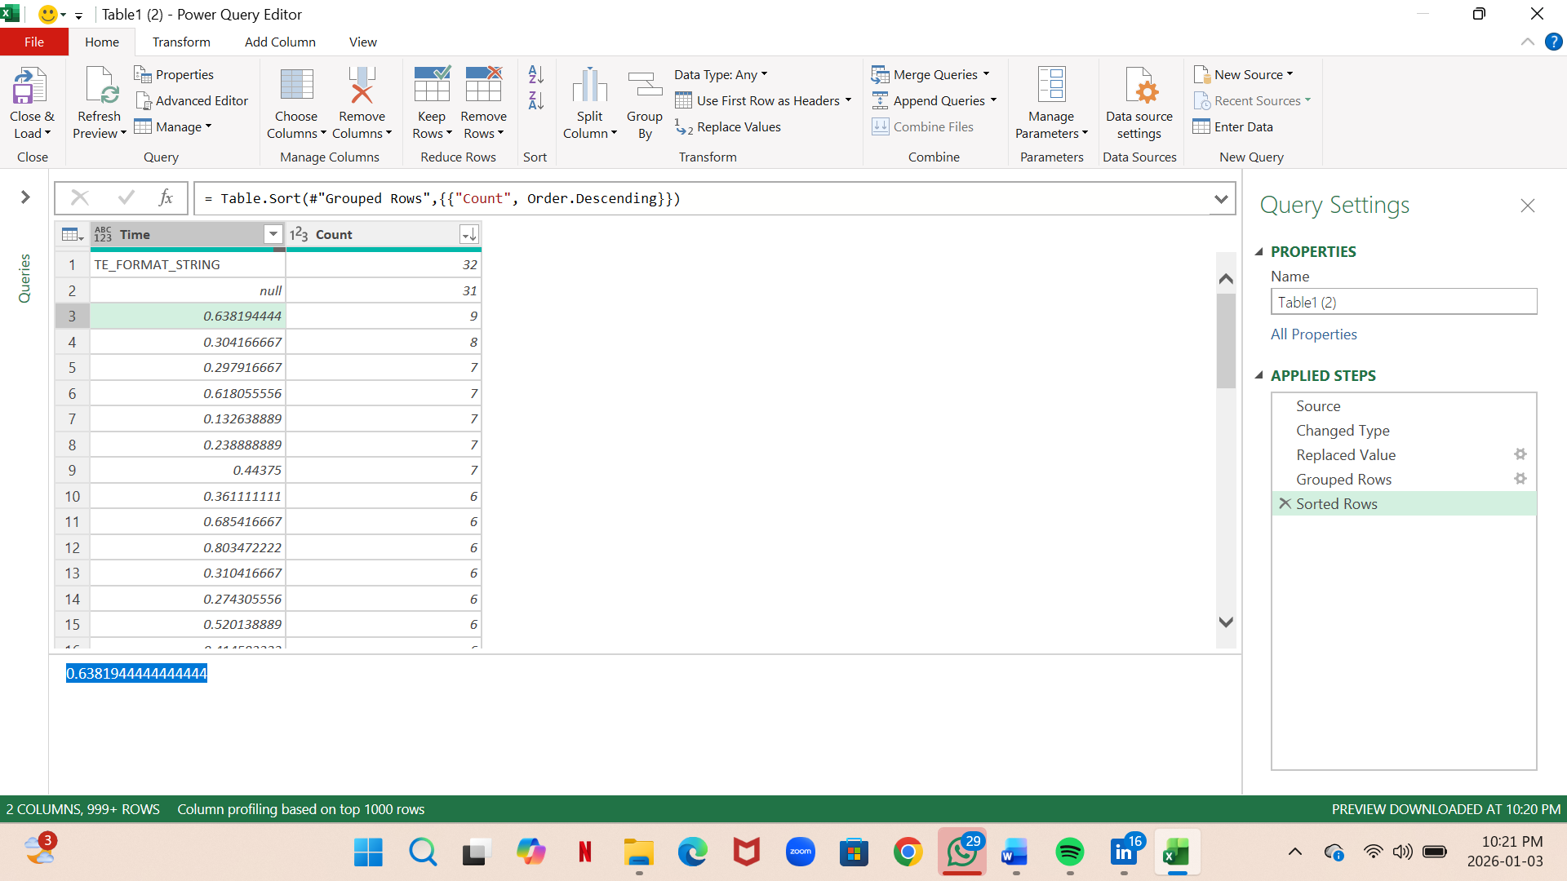

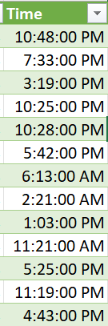

8.To find the INVALID_CATEGORY_DEFAULT in Transaction type: Used power query editor

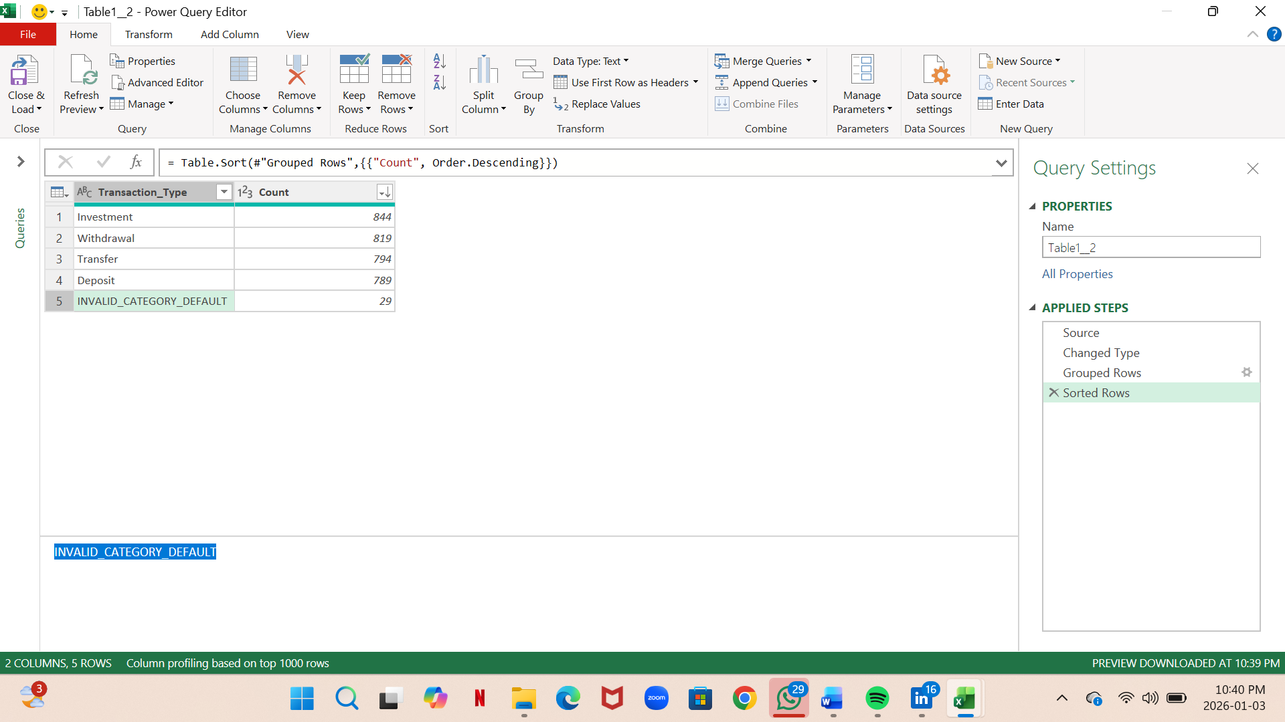

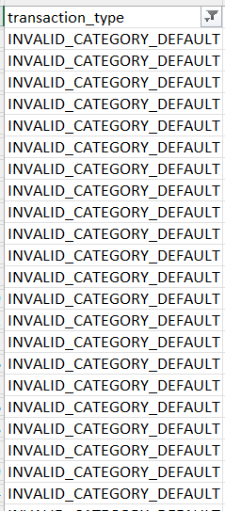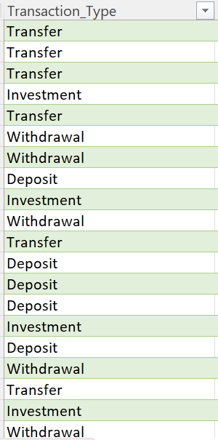

9.To find the missing value in transaction amount: Used average

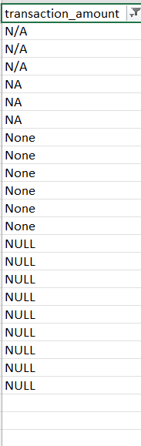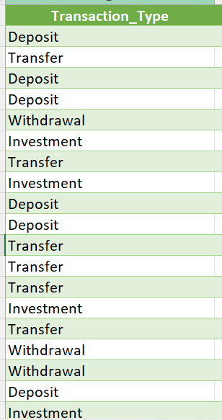

10.After cleaned in Excel I uploaded in Power BI and Prepared the below cards

Dax Formula : Total transaction amount

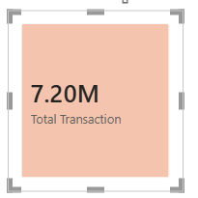

Dax Formula : Count transaction
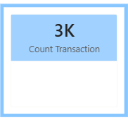
Dax Formula : Average interest rate
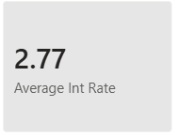
Dax Formula : Average Credit score

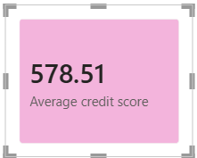

11.Pie Charts: The pie chart shows the average account balance by transaction type. Investment transactions maintain a significantly higher average account balance compared to deposits, transfers, and withdrawals, indicating that users tend to keep more funds allocated towards investments.

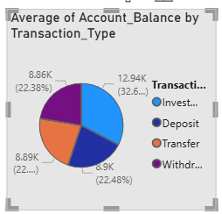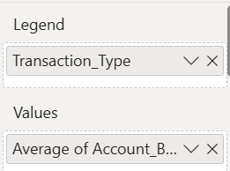

Key Insights
• Investment transactions have the highest average account balance, approximately ₹12.94K, contributing about 32.6% of the total.
• Deposit transactions account for an average balance of around ₹8.9K, making up nearly 22.48%.
• Transfer transactions show an average balance of approximately ₹8.89K, contributing about 22%.
• Withdrawal transactions have an average balance of nearly ₹8.86K, which is about 22.38% of the total.
12.Tree Map: Investment transactions involve the maximum overall risk, while deposit transactions are relatively safer and less risky. This indicates that as transaction types move towards investment-oriented activities, the associated risk level increases.

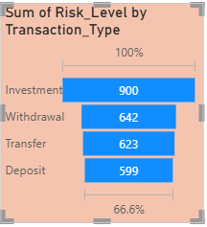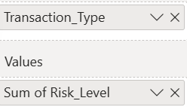
Key Insights
• Investment transactions have the highest risk level, with a total value of 900, indicating higher exposure compared to other transaction types.
• Withdrawal transactions show a total risk level of 642, making it the second highest.
• Transfer transactions have a slightly lower risk level of 623.
• Deposit transactions carry the lowest risk, with a total value of 599.
13. Column Chart: Investment-related transactions are more sensitive to market volatility, whereas deposits, transfers, and withdrawals are comparatively stable with lower volatility impact.

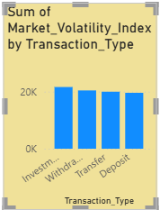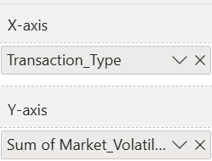

Key Insights
• Investment transactions show the highest market volatility, with values slightly above 20K, indicating higher exposure to market fluctuations.
• Withdrawal, Transfer, and Deposit transactions have almost similar volatility levels, close to 20K, showing moderate and stable market impact.
• Overall, the variation between non-investment transaction types is minimal compared to investments.

14. Line Chart: Interest rate impact is highest for investment transactions and decreases steadily for other transaction types, with transfer transactions being the least affected.

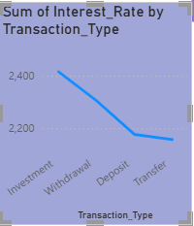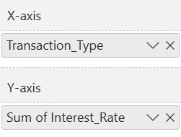

Key Insights
• Investment transactions have the highest total interest rate, around 2,400, indicating higher interest involvement.
• There is a gradual decline in interest rate from Withdrawal to Deposit transactions.
• Transfer transactions record the lowest sum of interest rate, showing minimal interest impact.
• Overall, the chart indicates a downward trend in interest rates across transaction types.

Summary:

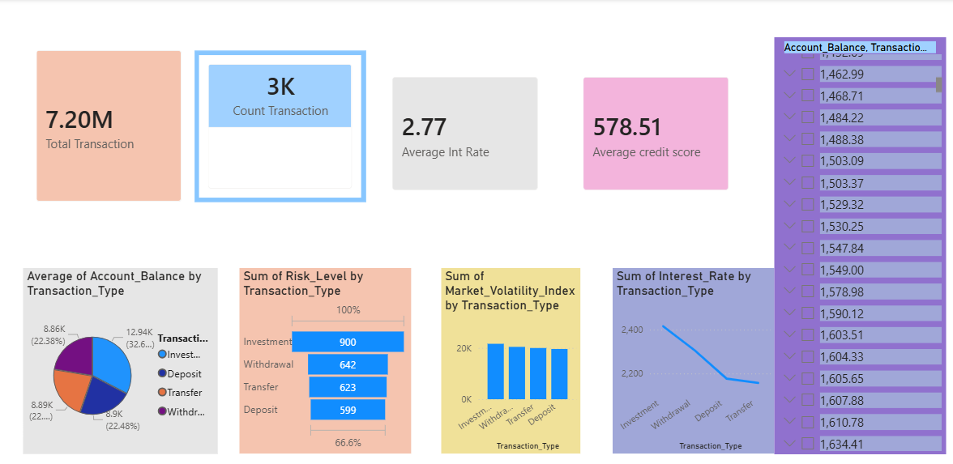

The dashboard presents a clear analysis of financial transactions across different transaction types. Investment transactions consistently show higher account balances, risk levels, interest rates, and market volatility compared to deposits, withdrawals, and transfers. Other transaction types display relatively stable and balanced behaviour with minimal variation. Trends across charts indicate that investment activities carry higher return potential along with increased risk, while non-investment transactions remain more conservative. Interactive slicers enable users to dynamically analyze transaction patterns by type, supporting effective financial decision-making.

